Azure VDI  
  
  
  
  
*Prepared By:  
 --Vatsal Patel*

**What Is VDI on Azure?**VDI (Virtual Desktop Infrastructure) on Azure refers to the deployment and management of virtual desktops using Microsoft Azure's cloud infrastructure. VDI allows organizations to create virtualized desktop environments that can be accessed remotely by users on various devices, such as laptops, tablets, and thin clients. By implementing VDI on Azure, businesses can take advantage of the scalability, flexibility, and cost-effectiveness of the Azure cloud platform for their virtual desktop needs. **Host pools:**A host pool is a collection of Azure virtual machines that register to Azure Virtual Desktop as session hosts when you run the Azure Virtual Desktop agent. All session host virtual machines in a host pool should be sourced from the same image for a consistent user experience.  
**A host pool can be one of two types:**Personal, where each session host is assigned to an individual user. Personal host pools provide dedicated desktops to end-users that optimize environments for performance and data separation.  
Pooled, where user sessions can be load balanced to any session host in the host pool. There can be multiple different users on a single session host at the same time. Pooled host pools provide a shared remote experience to end-users, which ensures lower costs and greater efficiency.  
**Application groups:**An application group is a logical grouping of applications installed on session hosts in the host pool.

An application group can be one of two types:

* RemoteApp, where users access the applications, you individually select and publish to the application group. Available with pooled host pools only.
* Desktop, where users access the full desktop. Available with pooled or personal host pools.

**Workspaces:**

A workspace is a logical grouping of application groups in Azure Virtual Desktop. Each Azure Virtual Desktop application group must be associated with a workspace for users to see the desktops and applications published to them.

**Prerequisites:**

* An Azure account with an active subscription. If you don't have an Azure subscription, create a [free account](https://azure.microsoft.com/free/?WT.mc_id=A261C142F) before you begin.
* The Azure account must be assigned the following built-in role-based access control (RBAC) roles as a minimum on the subscription, or on a resource group. For more information, see [Assign Azure roles using the Azure portal](https://learn.microsoft.com/en-us/azure/role-based-access-control/role-assignments-portal). If you want to assign the roles to a resource group, you need to create this first.

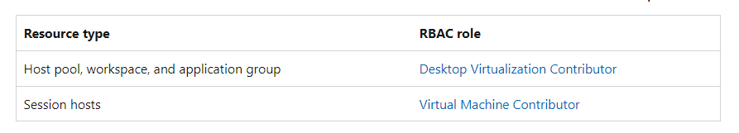

* A [virtual network](https://learn.microsoft.com/en-us/azure/virtual-network/quick-create-portal) in the same Azure region you want to deploy your session hosts to.
* A user account in Microsoft Entra ID you can use for connecting to the desktop. This account must be assigned the Virtual Machine User Login or Virtual Machine Administrator Login RBAC role on the subscription. Alternatively you can assign the role to the account on the session host VM or the resource group containing the VM after deployment.
* A Remote Desktop client installed on your device to connect to the desktop. You can find a list of supported clients in [Remote Desktop clients for Azure Virtual Desktop](https://learn.microsoft.com/en-us/azure/virtual-desktop/users/remote-desktop-clients-overview). Alternatively you can use the [Remote Desktop Web client](https://learn.microsoft.com/en-us/azure/virtual-desktop/users/connect-web), which you can use through a supported web browser without installing any extra software.

## Create a personal host pool, workspace, application group, and session host VM

To create a personal host pool, workspace, application group, and session host VM running Windows 11:

1. Sign in to the [Azure portal](https://portal.azure.com/).
2. In the search bar, type Azure Virtual Desktop and select the matching service entry.
3. From the Azure Virtual Desktop overview page, select **Create a host pool**.
4. On the **Basics** tab, complete the following information.

Once you've completed this tab, select **Next: Virtual Machines**.

1. On the **Virtual machines** tab, complete the following information:

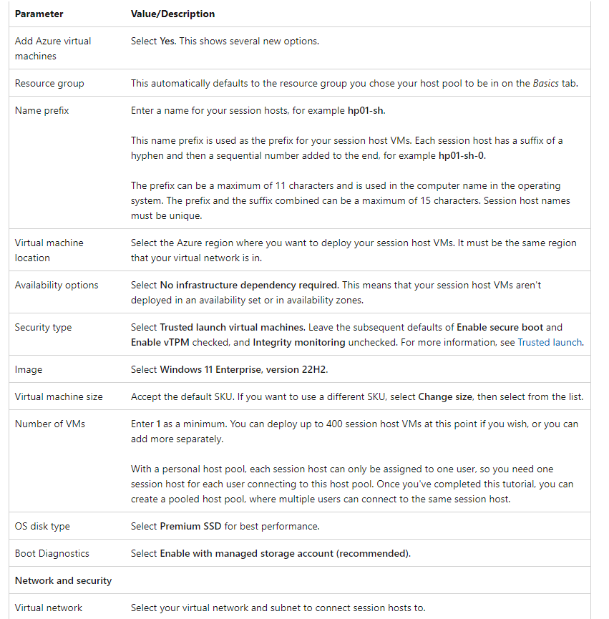

Once you've completed this tab, select **Next: Workspace**.

1. On the **Workspace** tab, complete the following information:

Once you've completed this tab, select **Next: Review + create**. You don't need to complete the other tabs.

1. On the **Review + create** tab, ensure validation passes and review the information that is used during deployment. If validation doesn't pass, review the error message and check what you entered in each tab.
2. Select **Create**. A host pool, workspace, application group, and session host is created. Once your deployment is complete, select **Go to resource** to go to the host pool overview.
3. Finally, from the host pool overview, select **Session hosts** and verify the status of the session hosts is **Available**.

## Assign users to the application group

Once your host pool, workspace, application group, and session host VM(s) have been deployed, you need to assign users to the application group that was automatically created. After users are assigned to the application group, they'll automatically be assigned to an available session host VM because Assignment type was set to **Automatic** when the host pool was created.

1. From the host pool overview, select **Application groups**.
2. Select the application group from the list, for example **hp01-DAG**.
3. From the application group overview, select **Assignments**.
4. Select **+ Add**, then search for and select the user account you want to be assigned to this application group.
5. Finish by selecting **Select**.

## Enable connections from Remote Desktop clients

To enable connections from all of the Remote Desktop clients, you need to add an RDP property to your host pool configuration.

1. Go back to the host pool overview, then select **RDP Properties**.
2. Select the **Advanced** tab.
3. In the **RDP Properties** box, add targetisaadjoined:i:1; to the start of the text in the box.
4. Select **Save**.

## 

## Connect to the desktop

You're ready to connect to the desktop. The desktop takes longer to load the first time as the profile is being created, however subsequent connections are quicker.

* [Windows](https://learn.microsoft.com/en-us/azure/virtual-desktop/tutorial-try-deploy-windows-11-desktop?tabs=windows-client#tabpanel_1_windows-client)

1. Open the **Remote Desktop** app on your device.
2. Select the three dots in the top right-hand corner, then select **Subscribe with URL**.
3. In the **Email or Workspace URL** box, enter https://rdweb.wvd.microsoft.com. After a few seconds, the message **We found Workspaces at the following URLs** should be displayed.
4. Select **Next**.
5. Sign in with the user account you assigned to the application group. After a few seconds, the workspace should show with an icon named **SessionDesktop**.
6. Double-click **SessionDesktop** to launch a desktop session. You need to enter the password for the user account again.